Assignment

Azure Databricks Components Creation in Azure DataBricksAccount

**Workspace:**WorkSpace is an environment where we can access all the databricks assests.

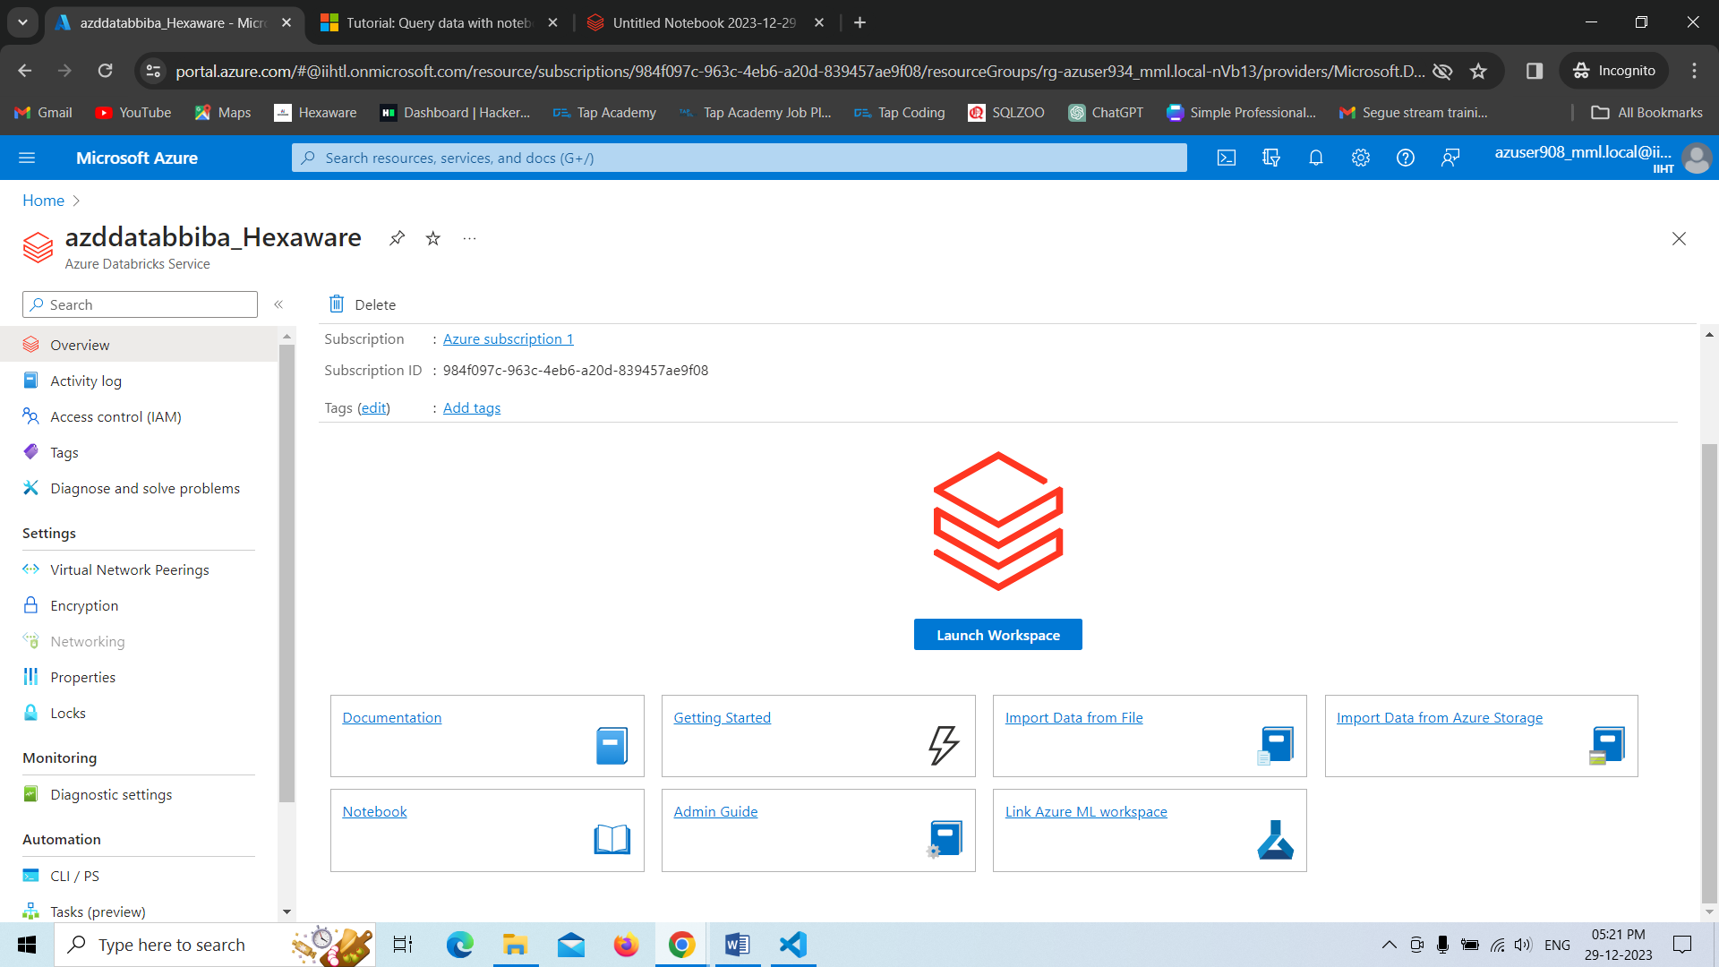

**Cluster:**It is a collection of Databricks Computation Resources.

**Creating a cluster.**

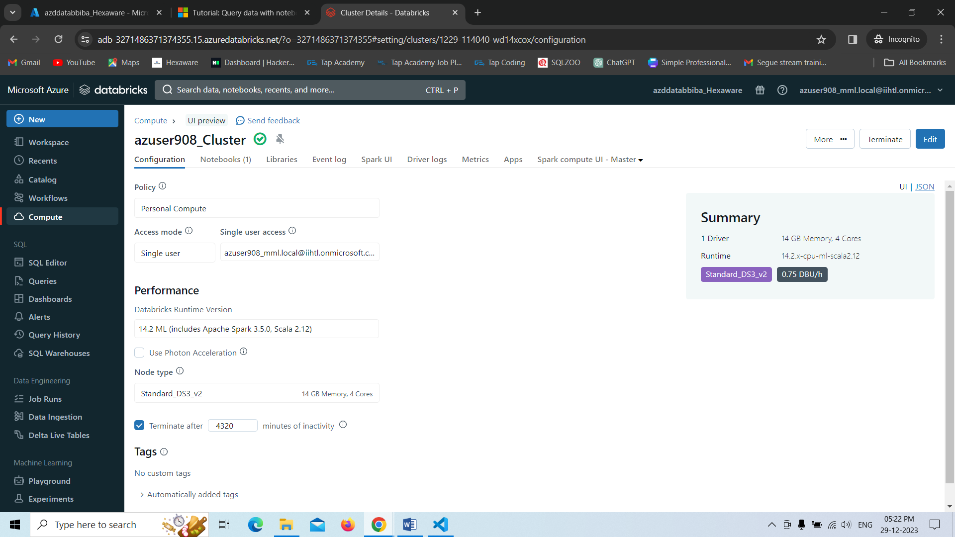

**Notebook:** Notebook is a combination of cells that contain certain script in order to execute.

**Creating a Notebook:**

* Here we have created a notebook and run demo script in the cell of that notebook.
* In order to execute the things in notebook we need to attach that notebook to a cluster at that time only the note book will run and gives us output.

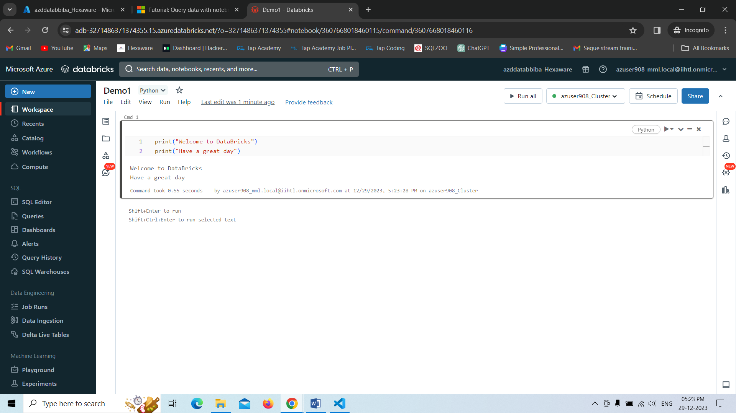

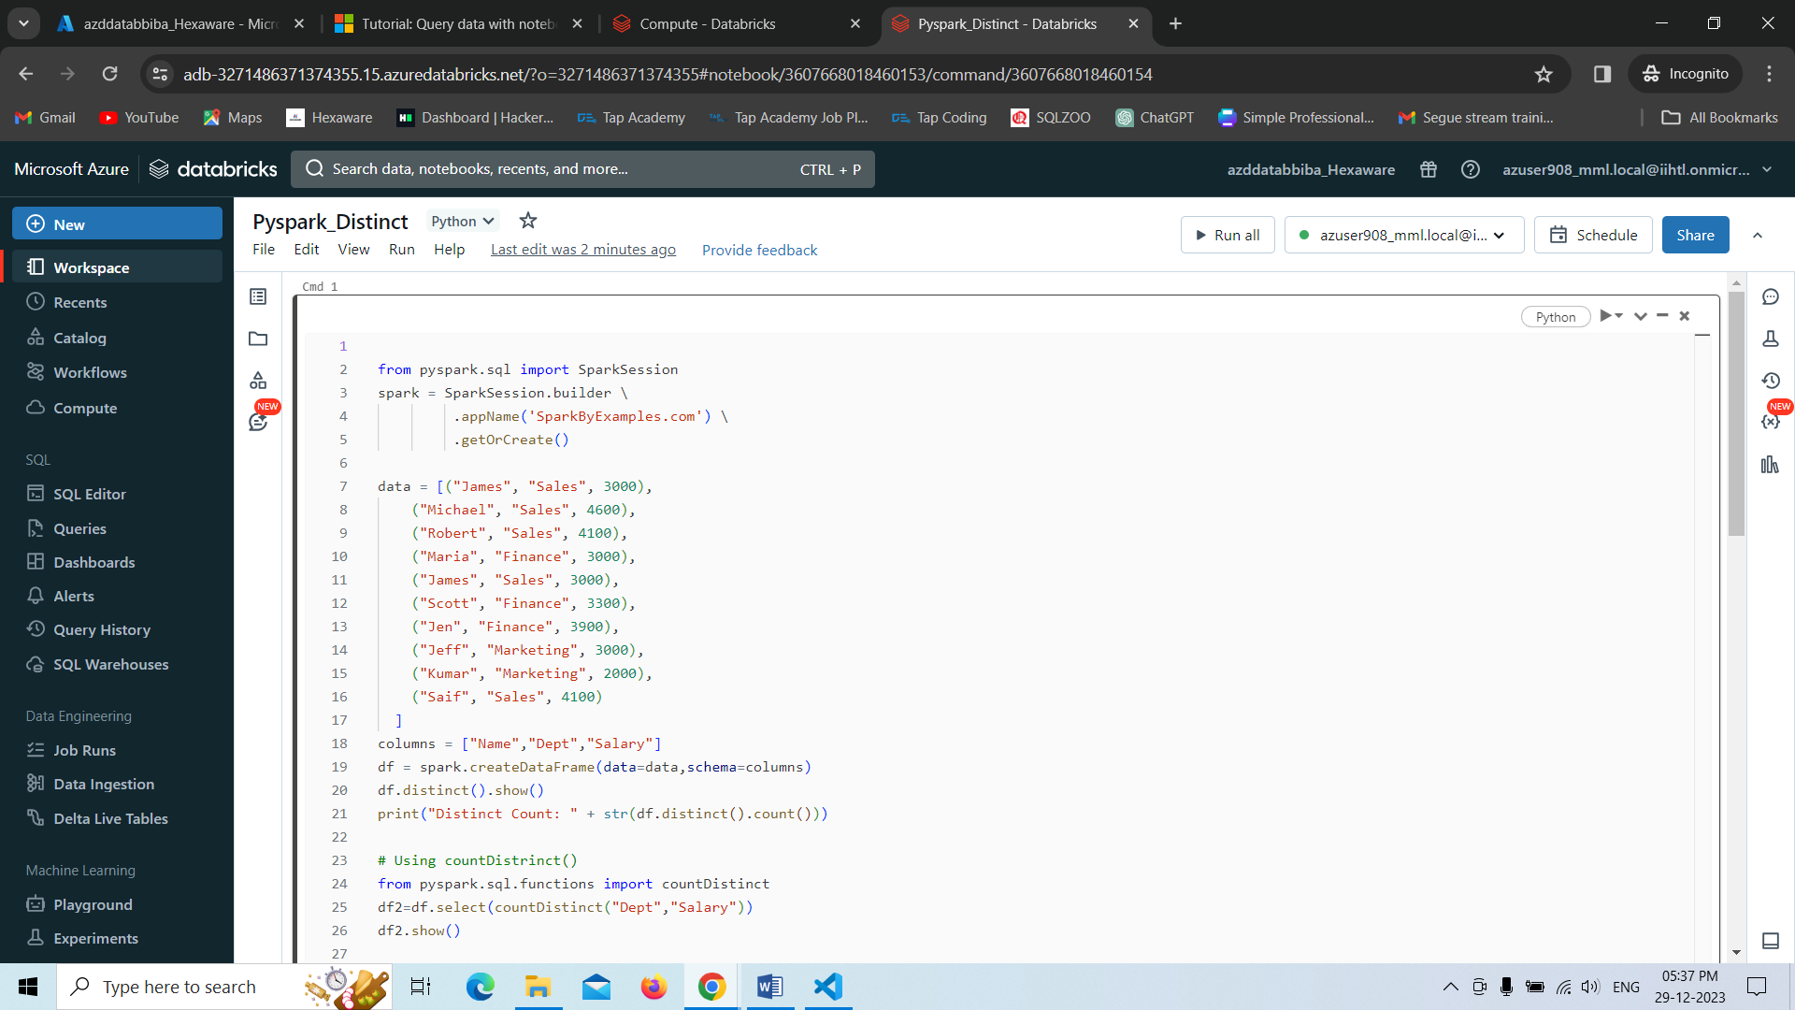

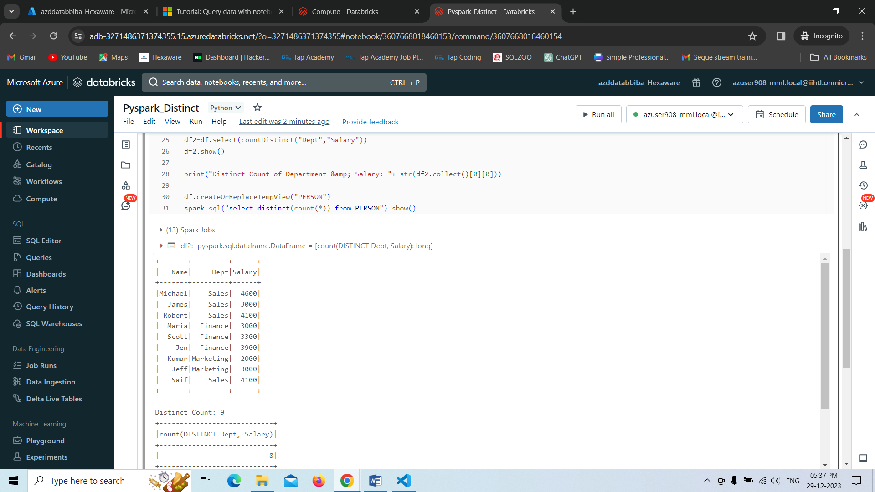

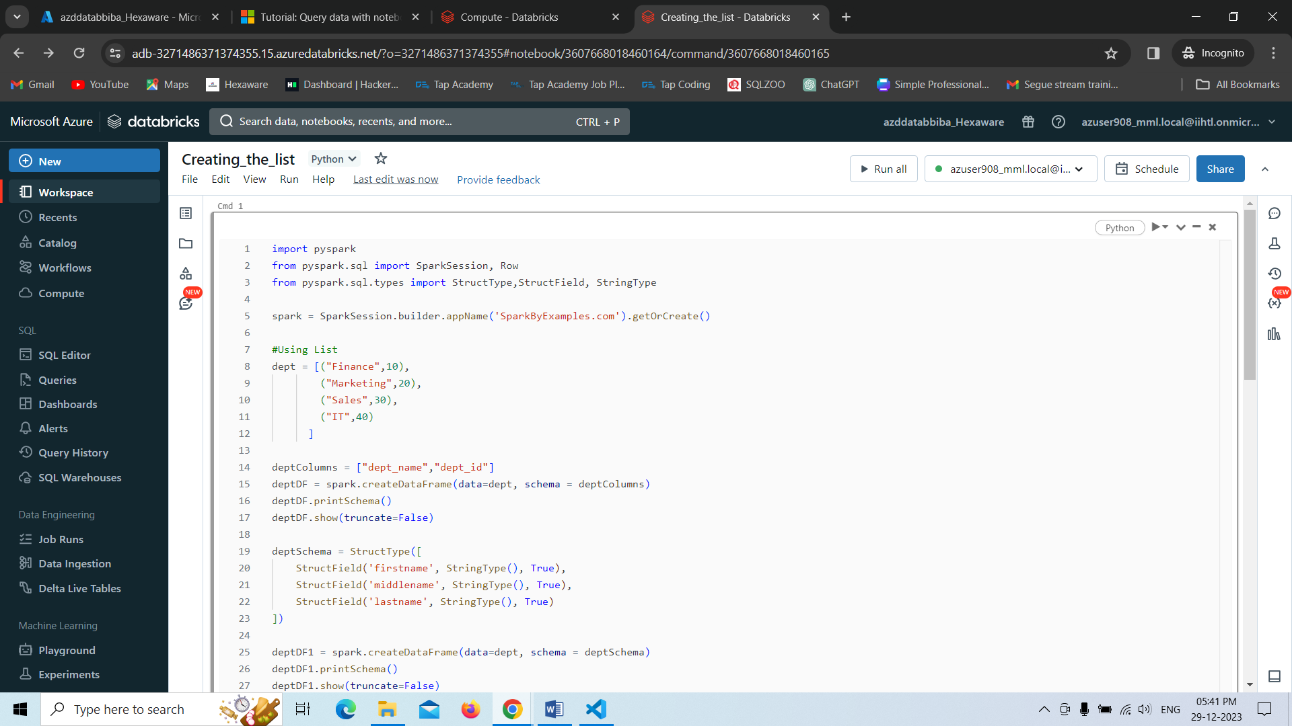

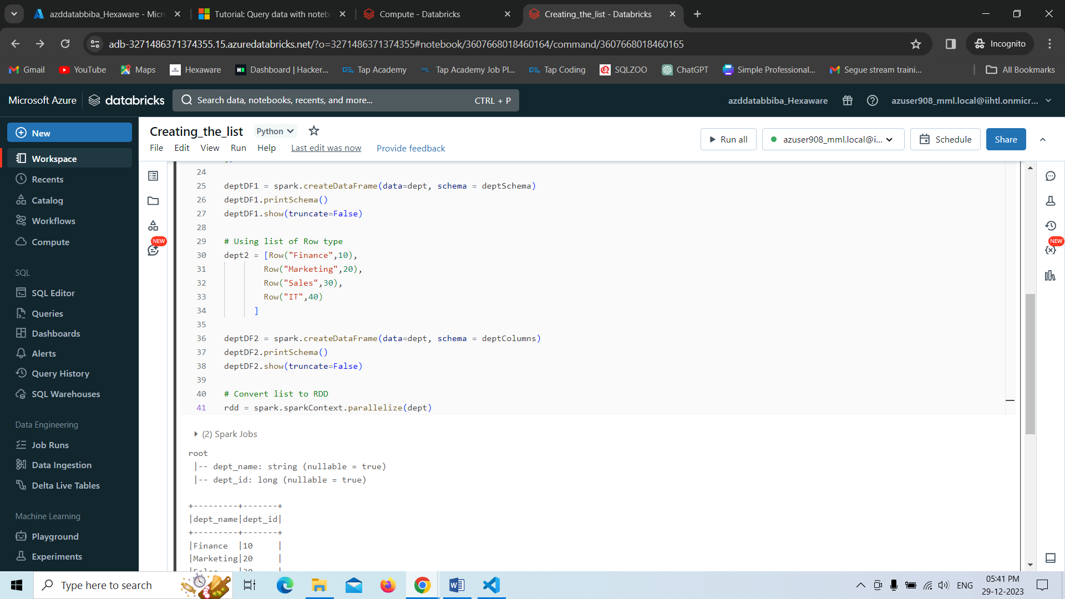

creating the dataframe and just displaying the result

